Ink blots



In this project, you will train robots to tell you what they can see in ink blots.

By training more than one robot, you’ll see that different machine learning models can give different answers to the same questions, depending on how they’ve been trained.

This project is a recreation of an AI research project from MIT. In making it for yourself, you’ll learn about an example of academic research in AI and the way that some people describe artificial intelligence systems.

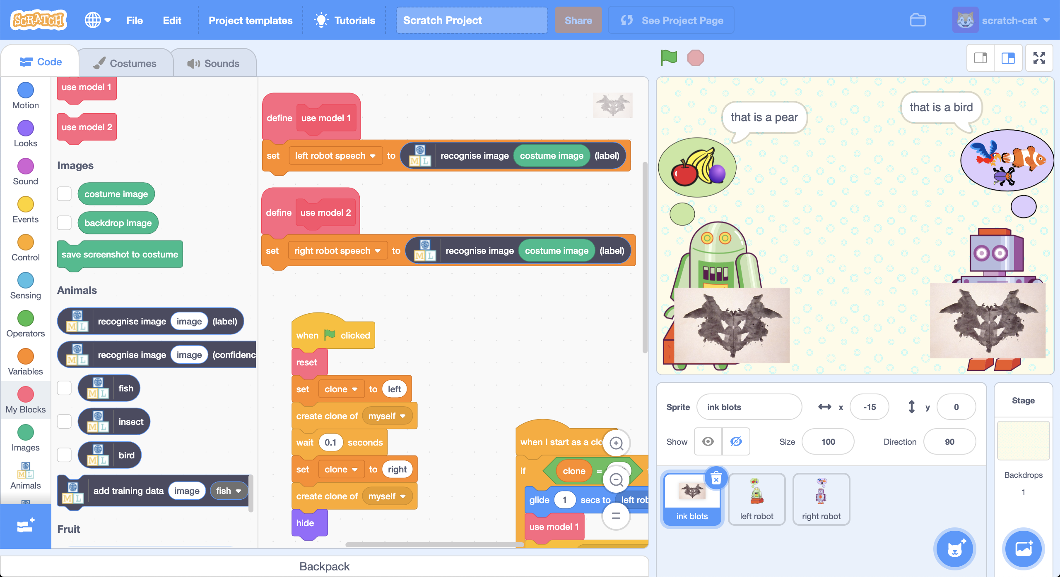

This project worksheet is licensed under a Creative Commons Attribution Non-Commercial Share-Alike License



http://creativecommons.org/licenses/by-nc-sa/4.0/

This project is for two students, working together, each on their own computer  
If you don’t have a partner or two computers, you can do all the steps yourself.   
  
*These instructions are for “student 1”.   
(“Student 2” instructions start at step 22)*

1. (student 1) Go to <https://machinelearningforkids.co.uk/> in a web browser.
2. (student 1) Click on “**Get started**”.
3. (student 1) Click on “**Log In**” and type in a username and password.  
   ***Important:*** *You need to use the same username/password as “student 2”.*
4. (student 1) Click on “**Projects**” on the top menu bar.
5. (student 1) Click the **“+ Add a new project**” button.
6. (student 1) Name your project **“Fruits”**. Set it to learn to recognise “**images**”  
   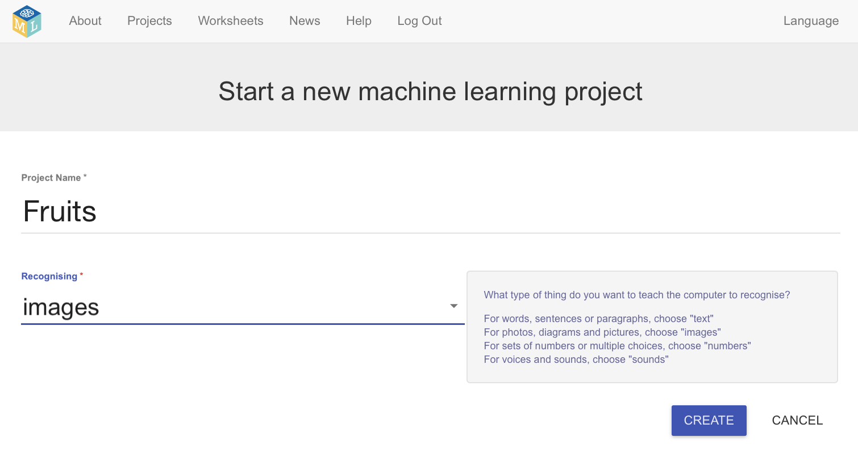
7. (student 1) Click the “**Create”** button.
8. (student 1) You should see **“Fruits”** in the list of your projects.   
   Click on it.
9. (student 1) Click the “**Train**” button to start collecting examples.  
   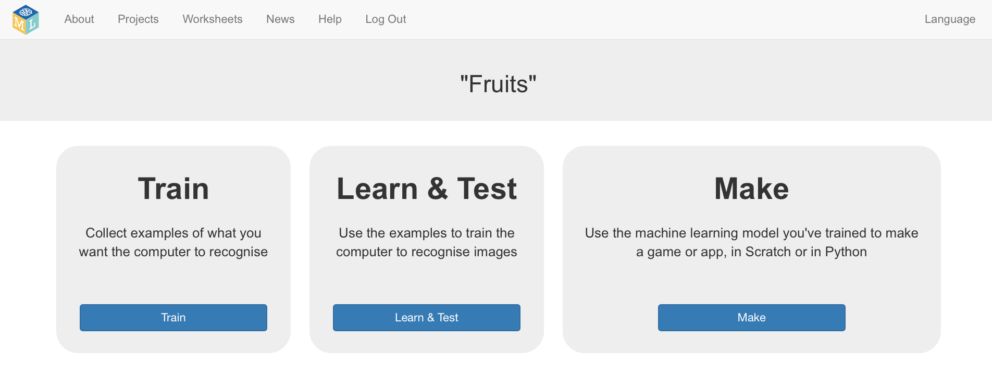
10. (student 1) Click on **“+ Add new label**” and create a label called “plum”.   
    Create a second bucket called “banana” and a third bucket called “pear”.  
    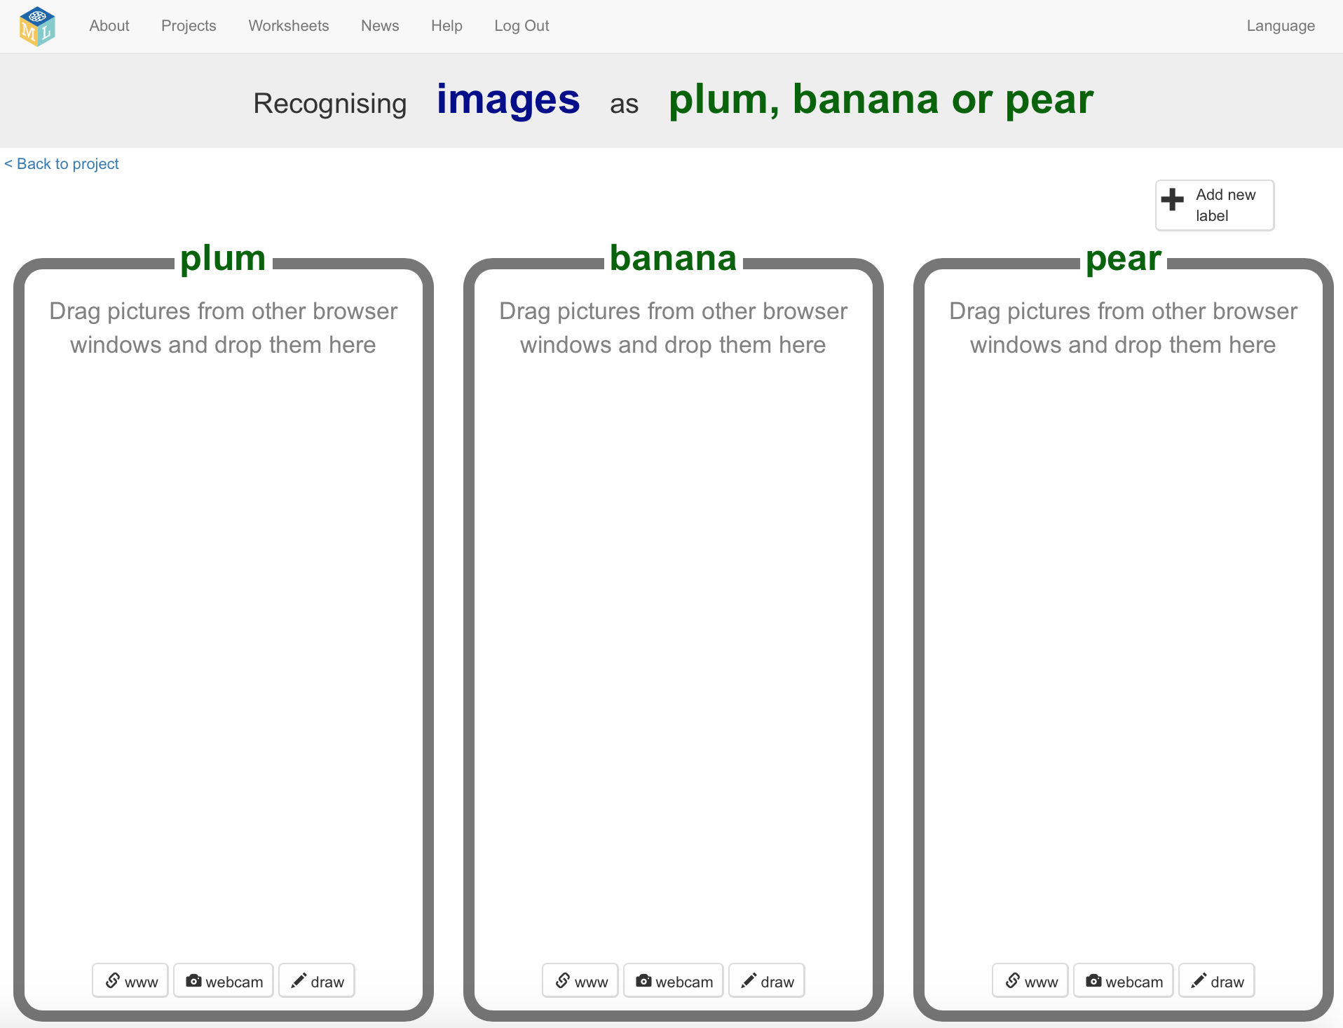
11. (student 1) Open another web browser window.
12. (student 1) Arrange the web browser windows so they are side by side.  
    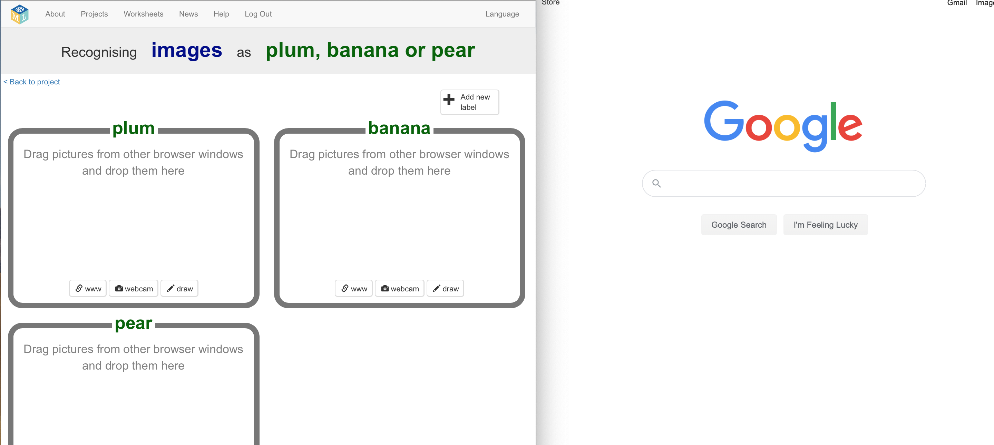
13. (student 1) In the new browser window, search for pictures of plums.   
    *Images of a single plum with a plain or blank background will work best.  
    Try searching for “single plum”.*
14. (student 1) Drag a picture from the new window into the training bucket for plums.

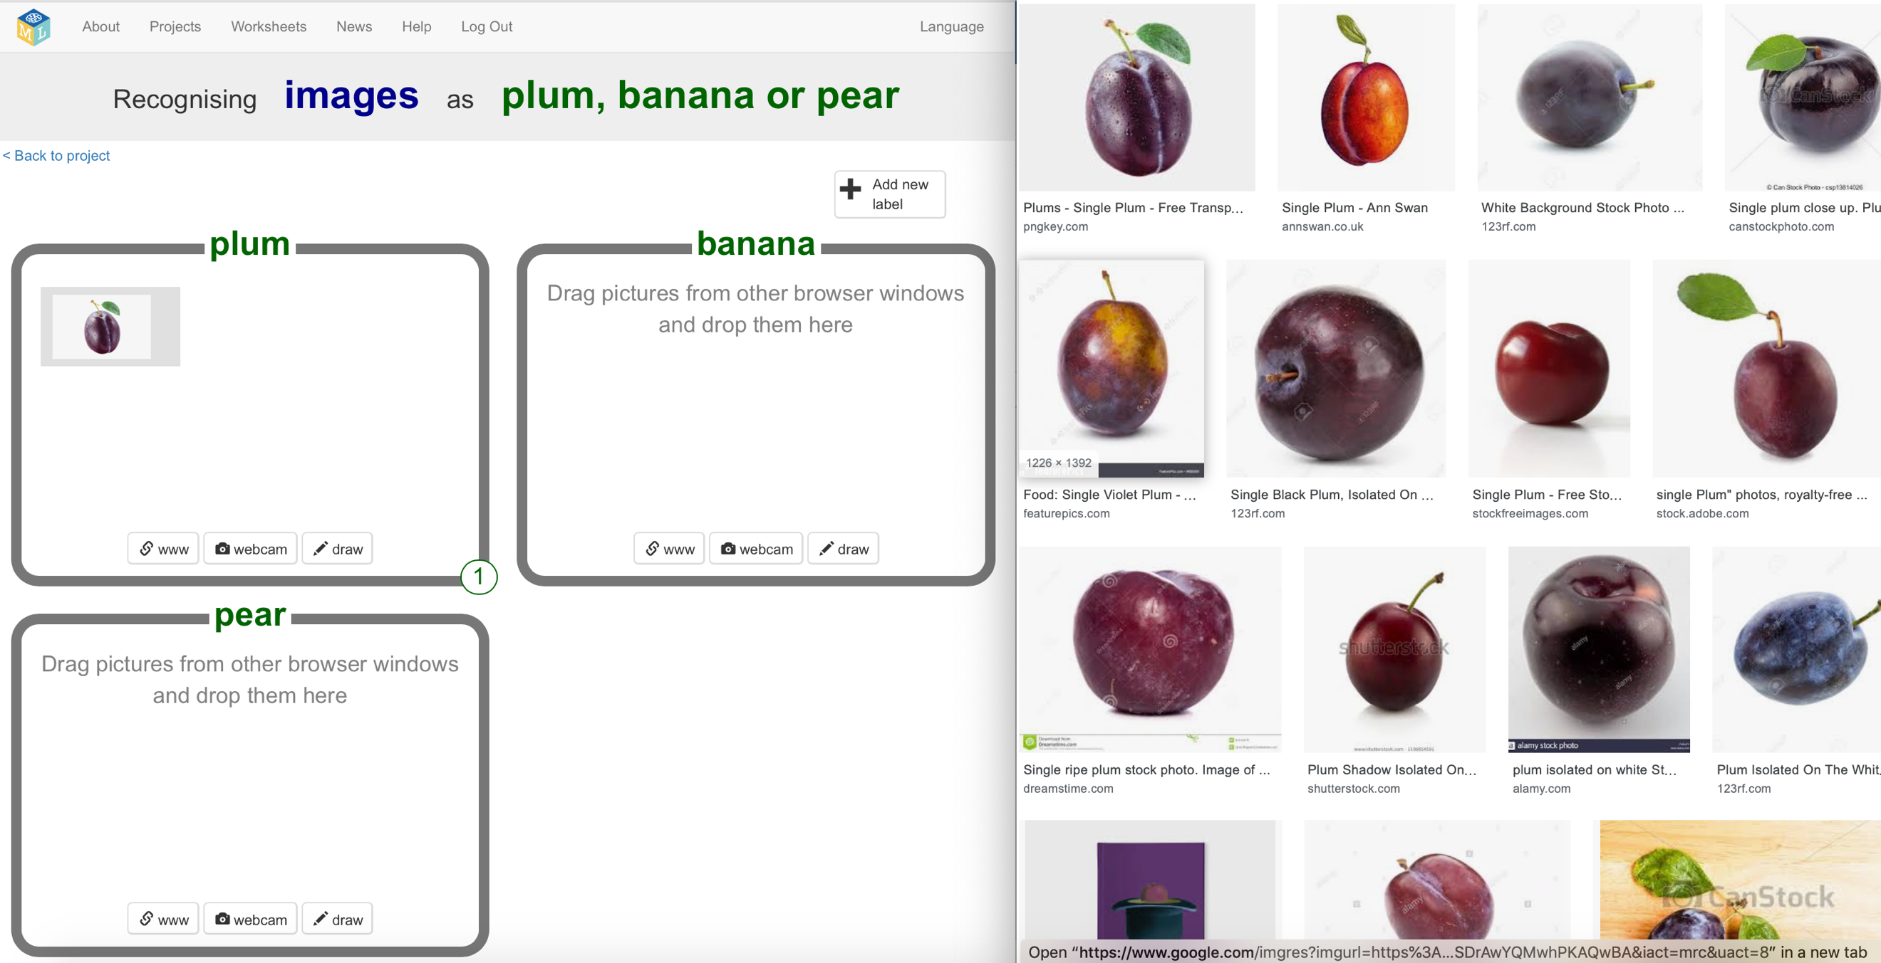

1. (student 1) Repeat until you’ve got 10 examples of pictures of plums.
2. (student 1) Repeat steps 13-15 for bananas and pears.  
     
   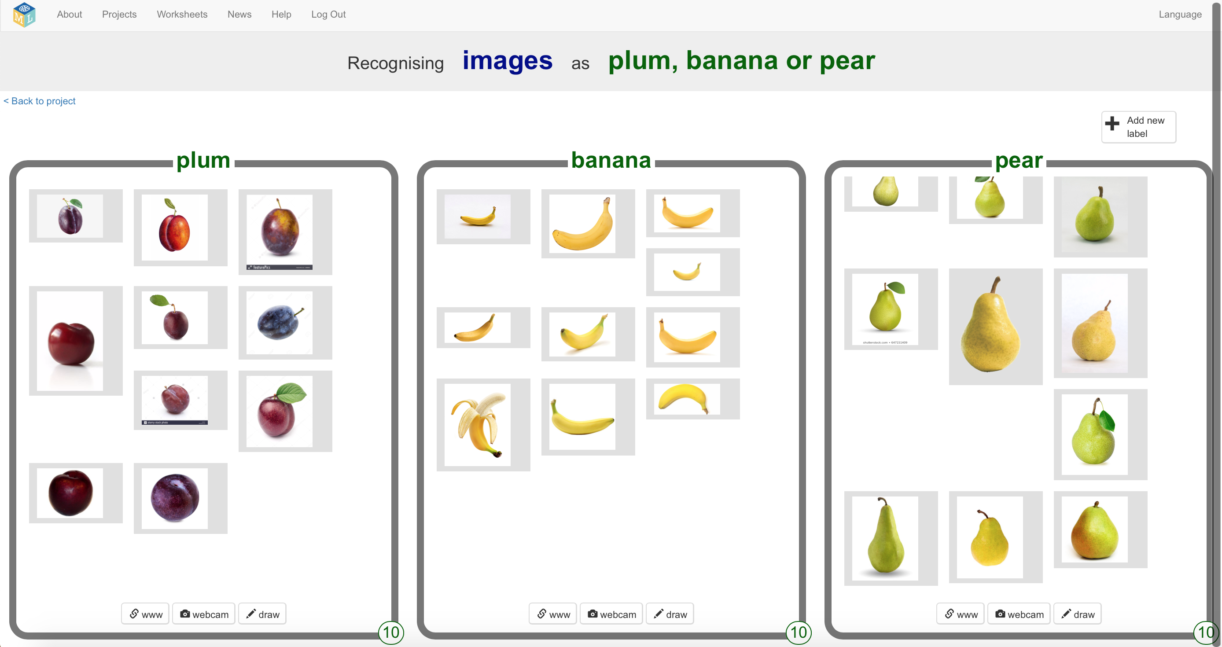
3. (student 1) Click the “**< Back to project**” link.
4. (student 1) Click the “**Learn & Test**” button.
5. (student 1) Click the “**Train new machine learning model**” button.  
   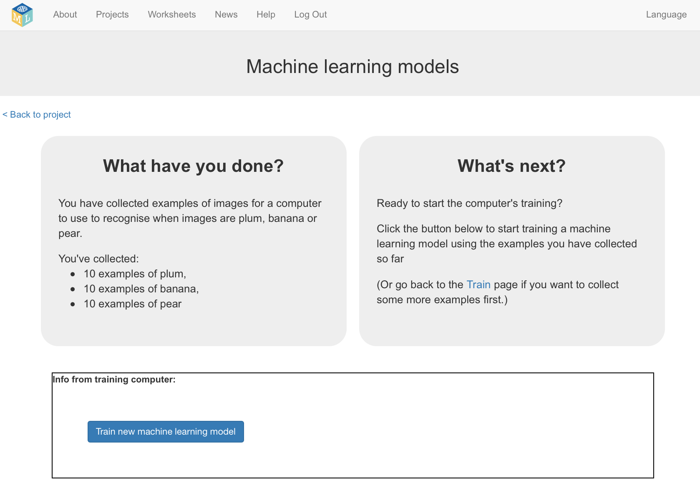
6. (student 1) Wait for the training to finish. This can take a few minutes.  
   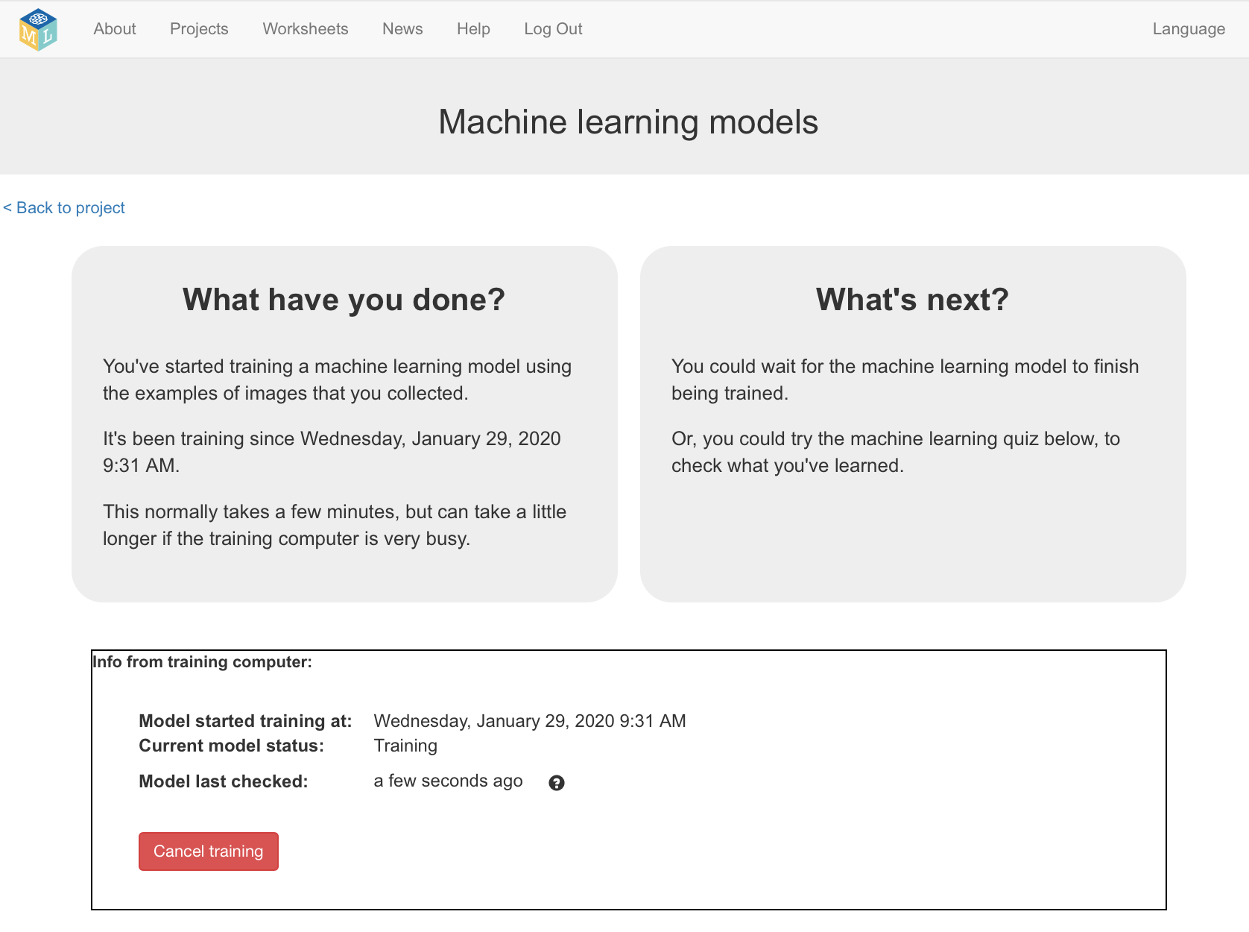
7. (student 1) Click the “**< Back to project**” link.

*Student 1 instructions continue at step 43*

*These instructions are for “student 2”.   
(“Student 1” instructions continue at step 43)*

1. (student 2) Go to <https://machinelearningforkids.co.uk/> in a web browser.
2. (student 2) Click on “**Get started**”.
3. (student 2) Click on “**Log In**” and type in a username and password.  
   ***Important:*** *You need to use the same username/password as “student 1”.*
4. (student 2) Click on “**Projects**” on the top menu bar.
5. (student 2) Click the **“+ Add a new project**” button.
6. (student 2) Name your project **“Animals”**. Set it to learn how to recognise “**images**”  
   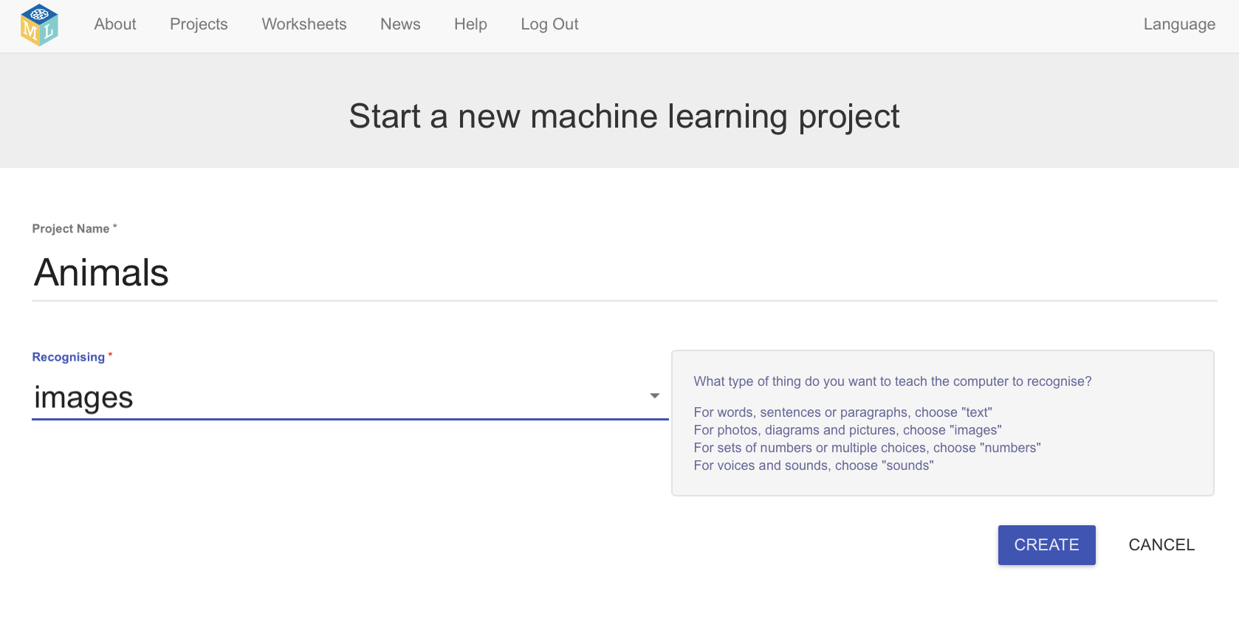
7. (student 2) Click the “**Create**” button.
8. (student 2) You should see **“Animals”** in the list of your projects.   
   Click on it.
9. (student 2) Click the “**Train**” button to start collecting examples.  
   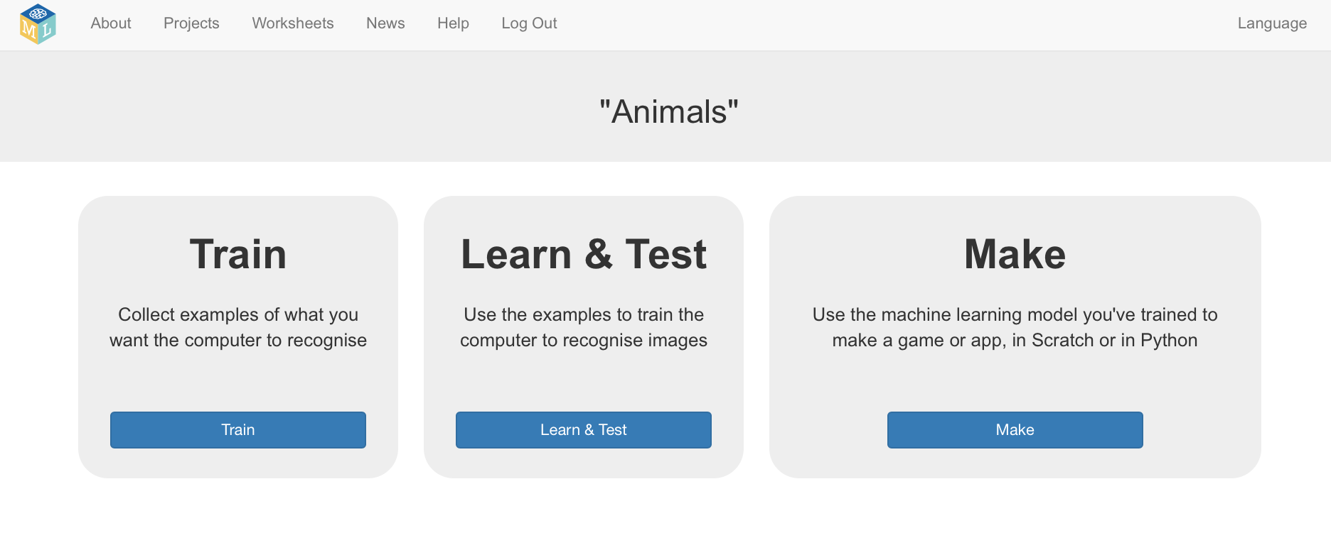
10. (student 2) Click on **“+ Add new label**” and create a bucket called “fish”.   
    Create a second bucket called “insect” and a third bucket called “bird”.  
    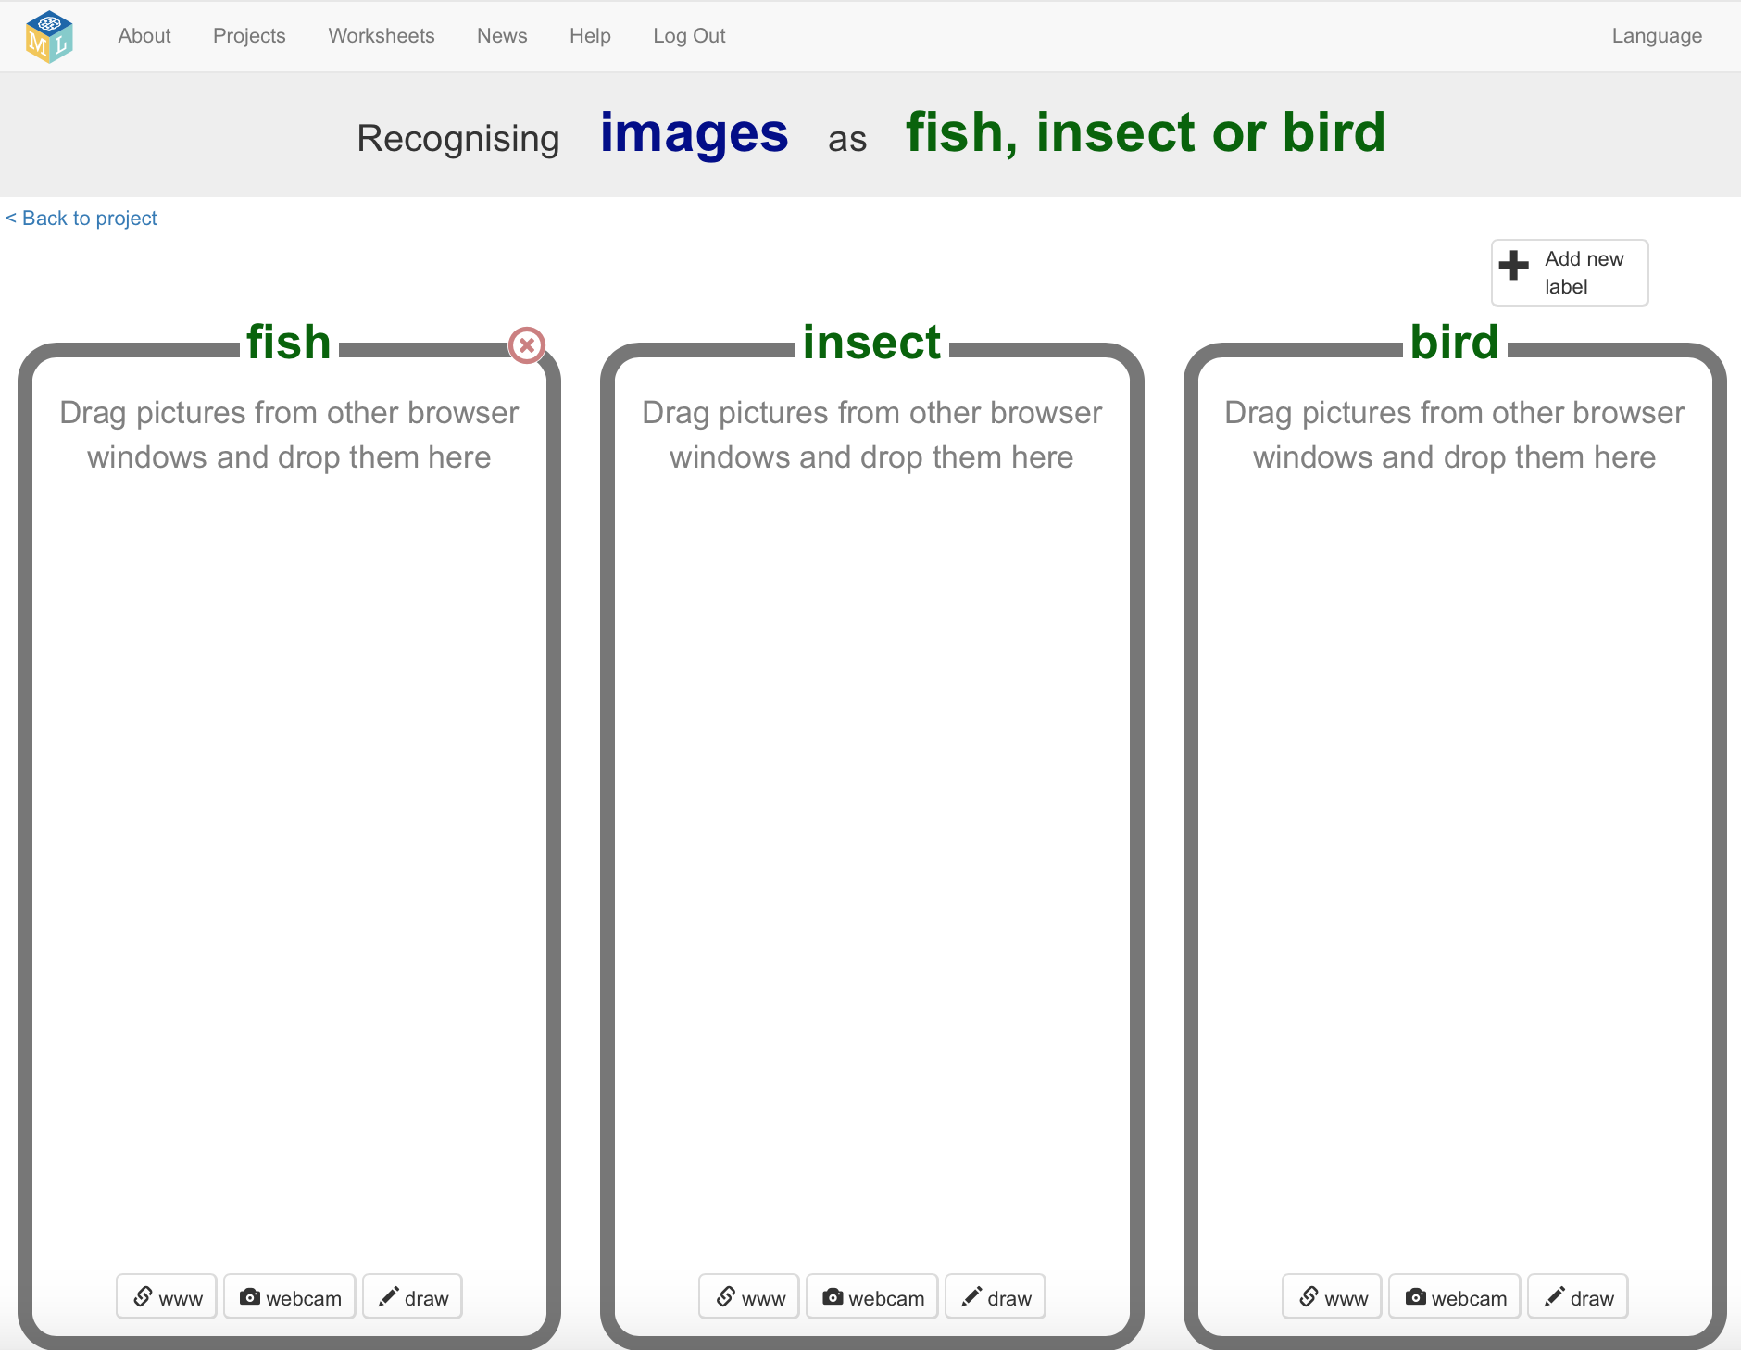

1. (student 2) Open another web browser window.
2. (student 2) Arrange the web browser windows so they are side by side.  
   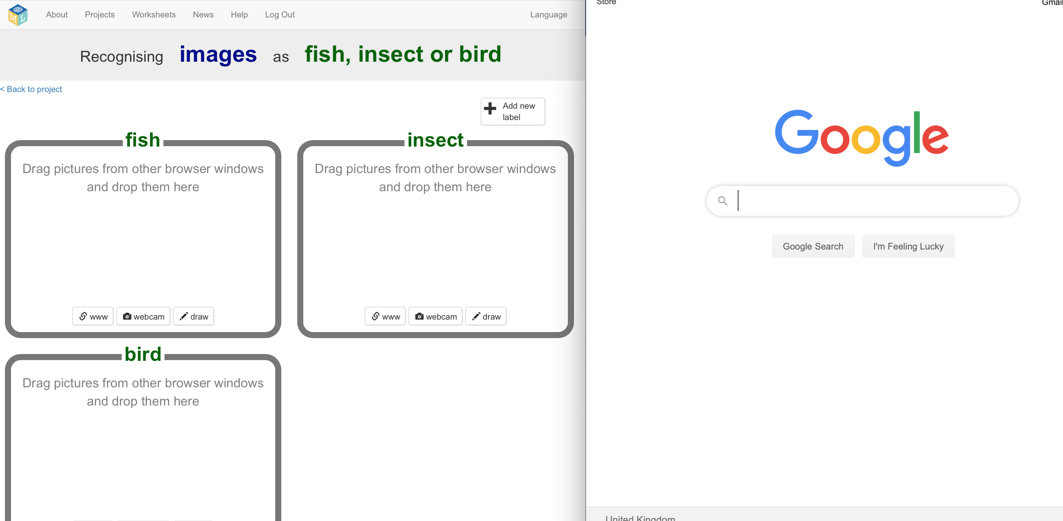
3. (student 2) In the new browser window, search for pictures of fish.   
   *Images of a single fish with a plain or blank background will work best. Try searching for “single fish”.*
4. (student 2) Drag a picture from the new window into the training bucket for fish.  
   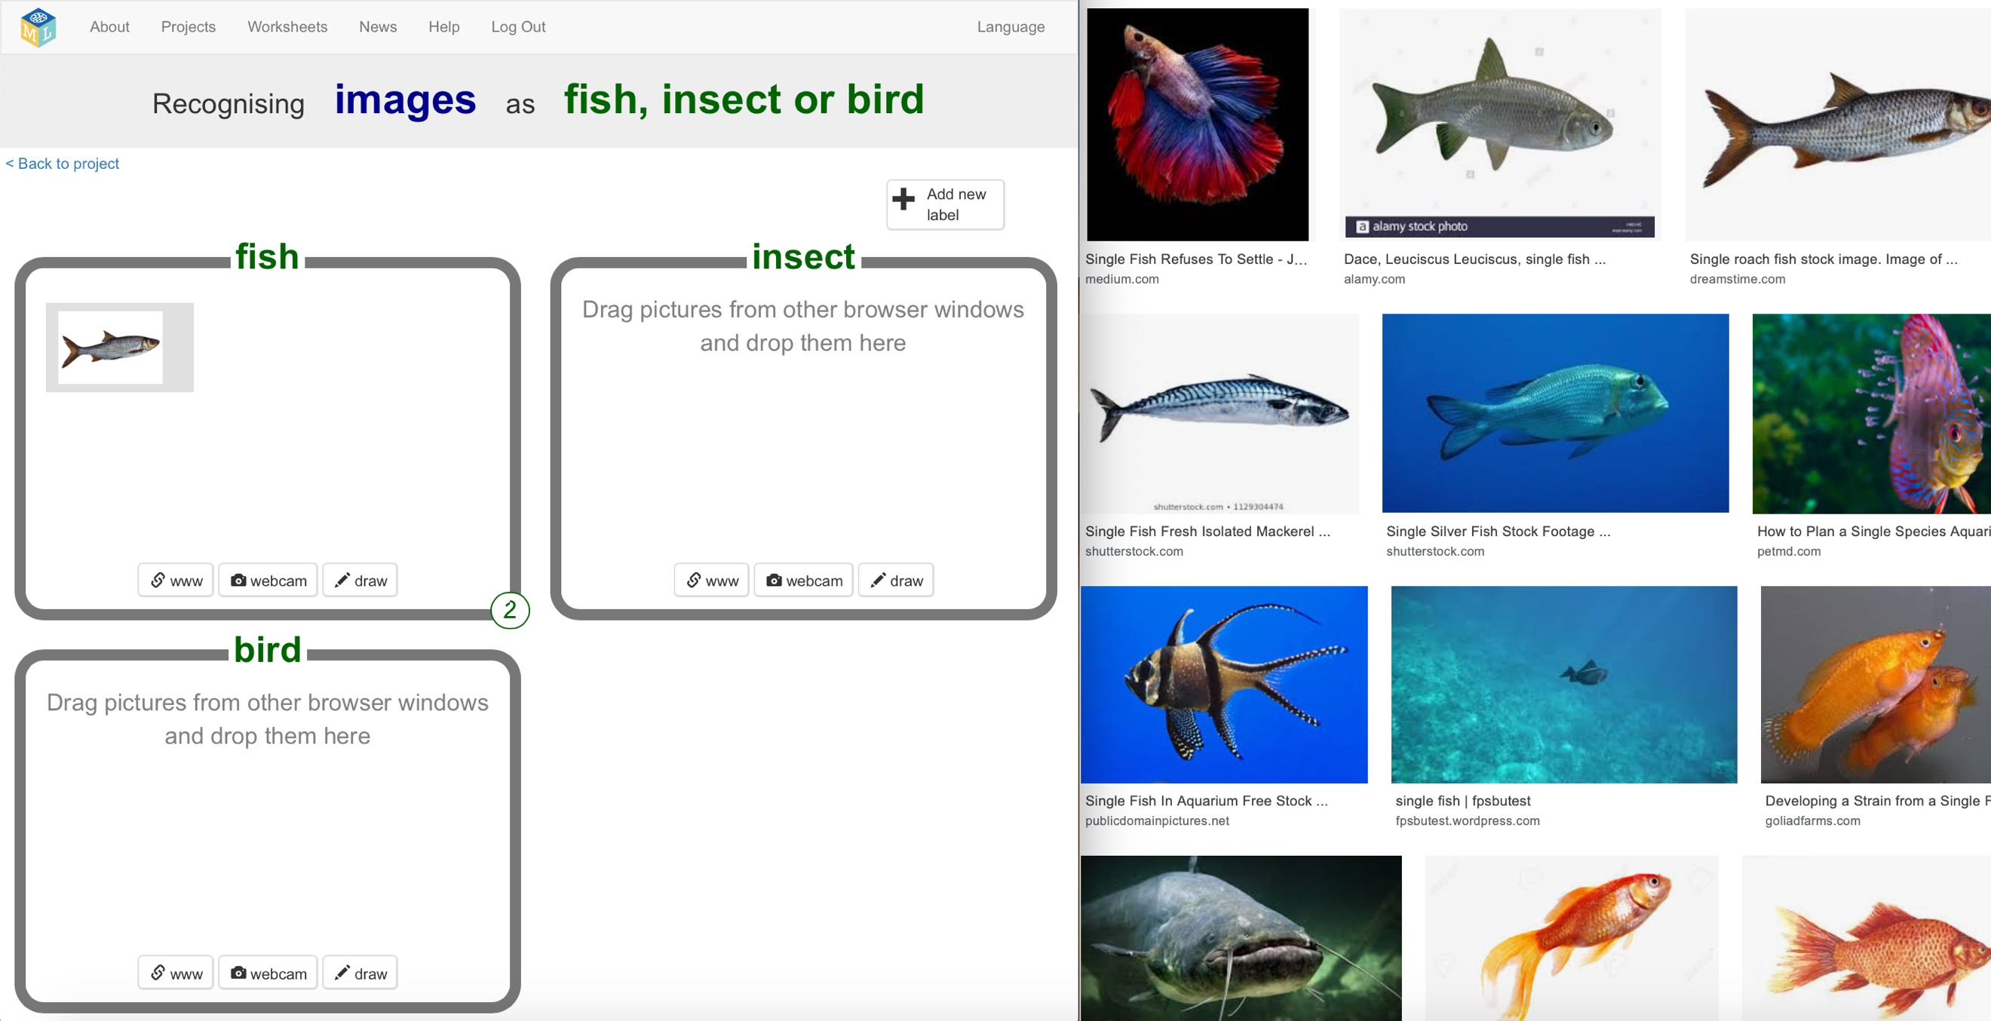
5. (student 2) Repeat until you’ve got 10 examples of pictures of fish.
6. (student 2) Repeat steps 33-35 for insects and birds.  
   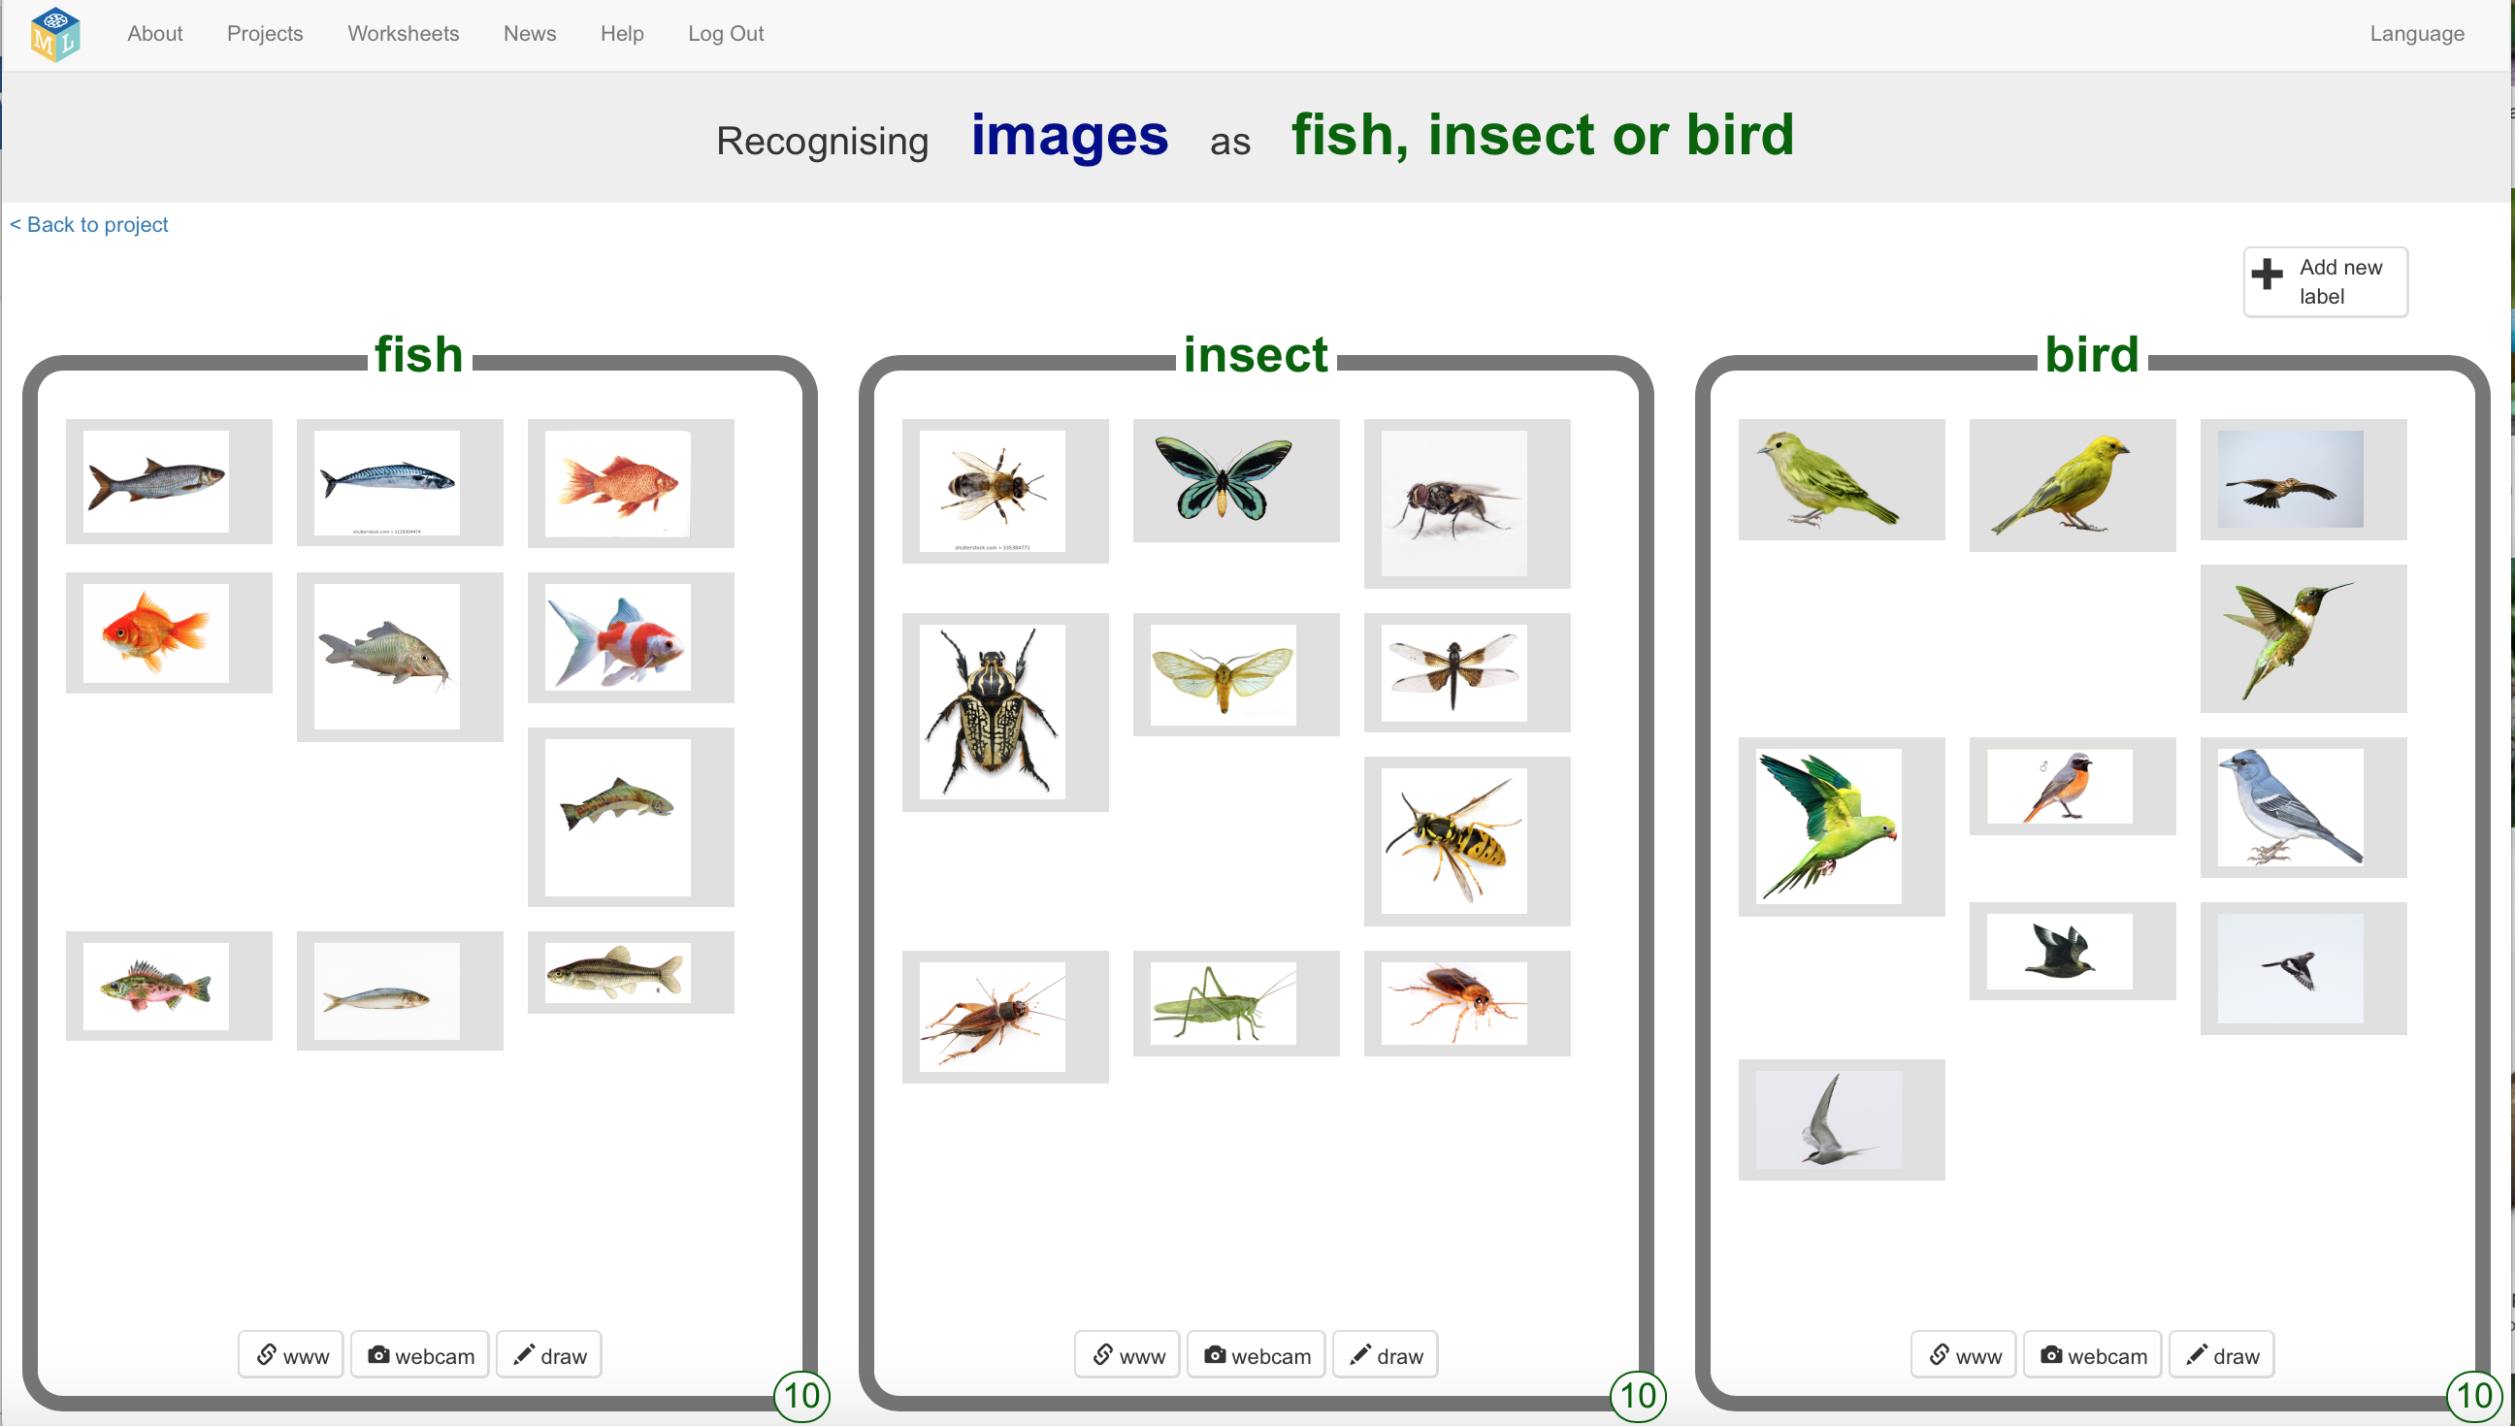
7. (student 2) Click the “**< Back to project**” link.
8. (student 2) Click the “**Learn & Test**” button
9. (student 2) Click the “**Train new machine learning model**” button  
   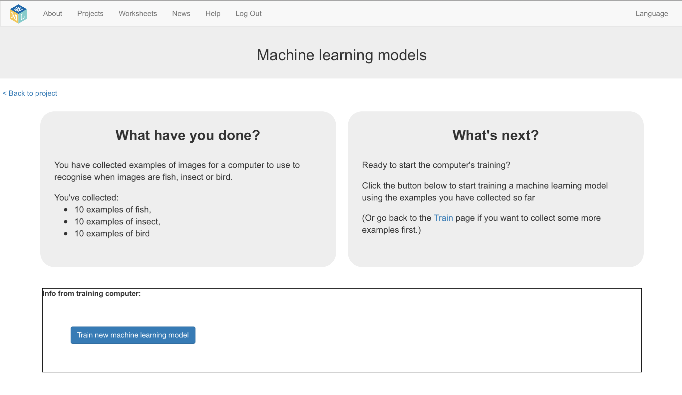
10. (student 2) Wait for the training to finish. This can take a few minutes.  
    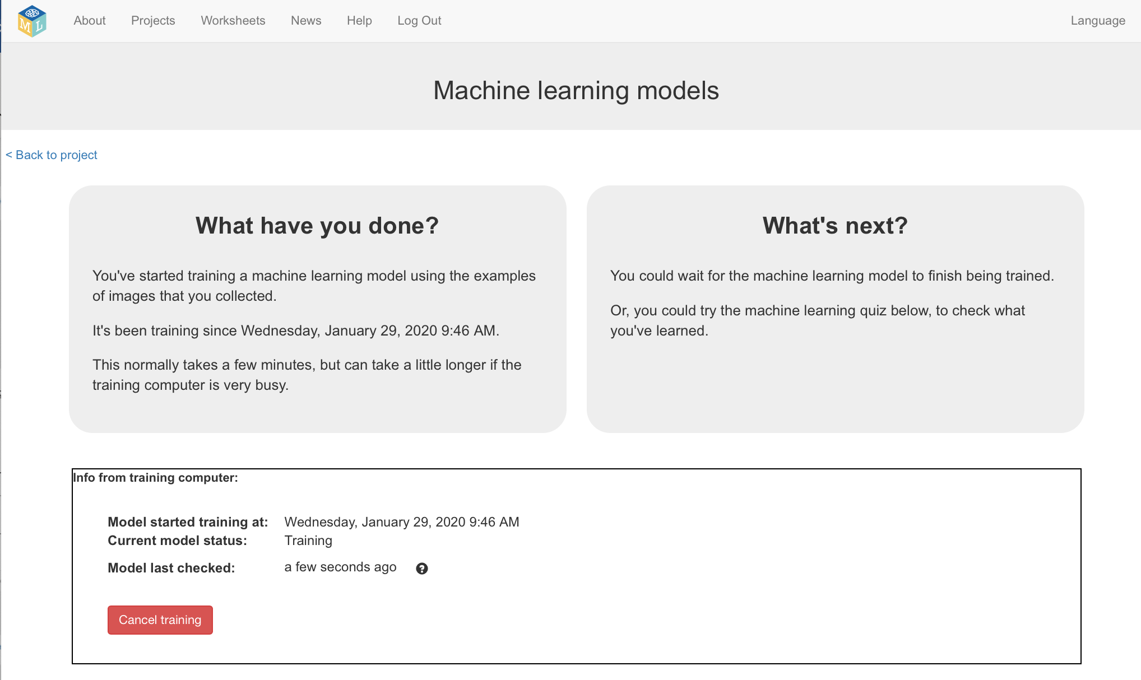
11. (student 2) Click the “**< Back to project**” link.

**What have you done so far?**

You’ve trained two different machine learning models.

One has been trained to recognize fruit in pictures. All it knows about is fruit.

The other has been trained to recognize animals in pictures. All it knows about are animals.

Next you’ll use these to control two different robots and see how differently they behave at the same tasks.

1. (BOTH students) Click the “**Make**” button  
   *Student 1 will be clicking “Make” in their Fruits project   
   Student 2 will be clicking “Make” in their Animals project*
2. (BOTH students) Click the “**Scratch 3**” button
3. (BOTH students) Click the “**Open in Scratch 3**” button.
4. (BOTH students) Open the **“Ink blots”** projecttemplate.  
   *Click on* ***Project templates*** *and then click on* ***Ink blots  
   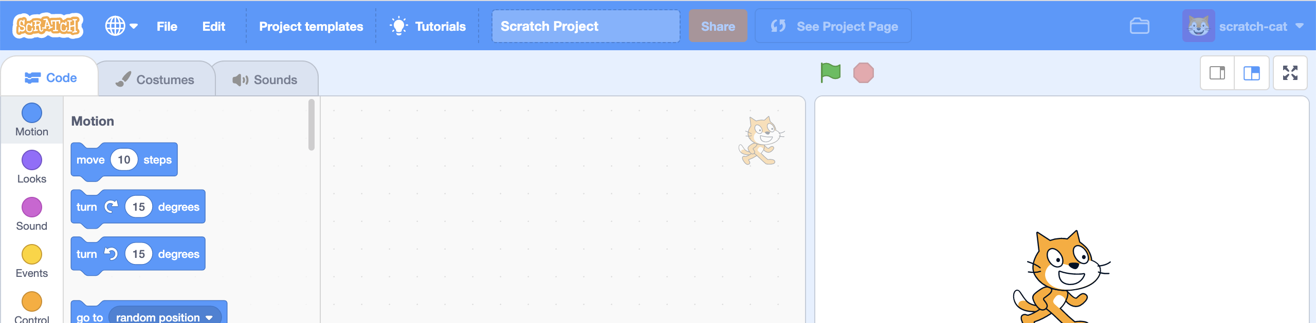***
5. (BOTH students) Save your template project to a file on your computer.  
   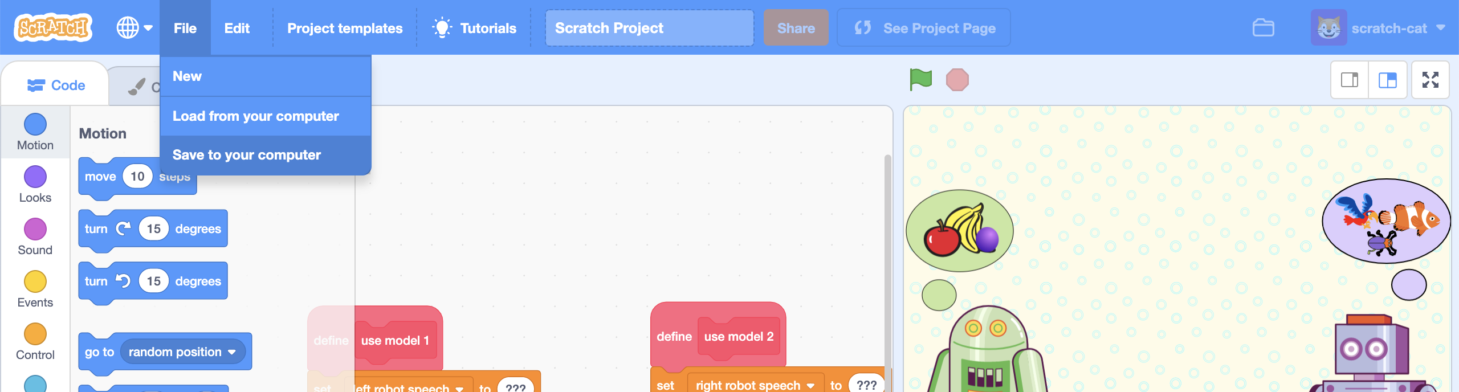
6. (BOTH students) Close the Scratch 3 window.
7. (BOTH students) On the training tool, click on “**Projects**” on the top menu   
   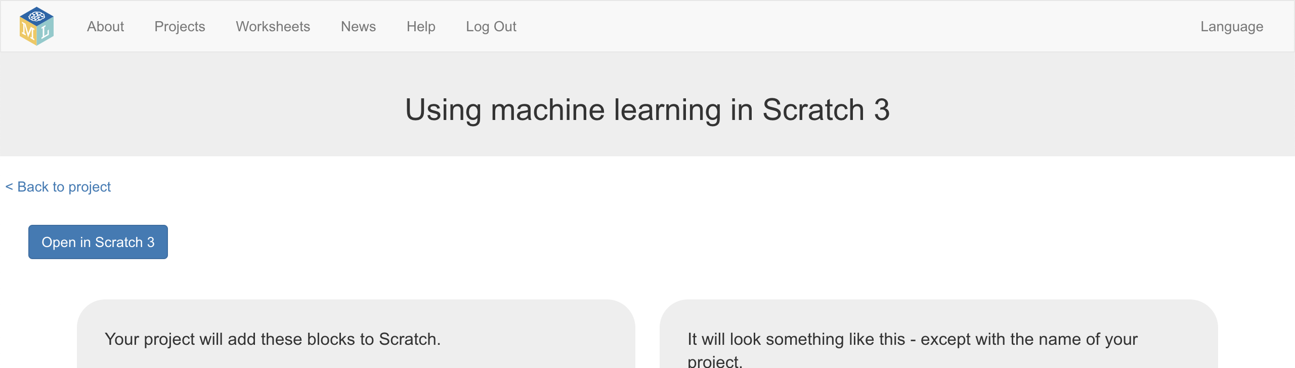
8. (student 1) Click on the “**Animals**” project  
   *This is the machine learning model that “student 2” trained.*
9. (student 2) Click on the “**Fruit**” project  
   *This is the machine learning model that “student 1” trained.*
10. (BOTH students) Click the “**Make**” button  
    *Student 1 will be clicking “Make” in the Animals project this time.  
    Student 2 will be clicking “Make” in the Fruit project this time.*
11. (BOTH students) Click the “**Scratch 3**” button
12. (BOTH students) Click the “**Open in Scratch 3**” button.
13. (BOTH students) Open the Scratch file that you saved in step 47.  
    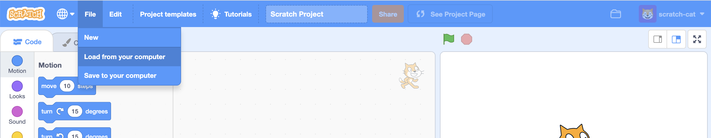
14. (BOTH students) Check the Animals & Fruit models are both in the toolbox  
    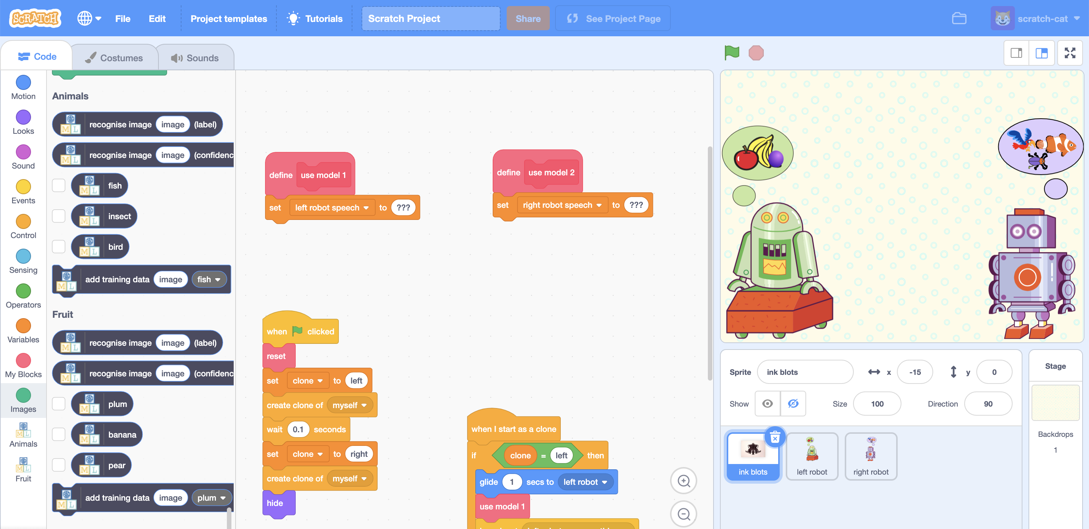
15. (BOTH students) Find the “**use model 1**” script in the ink blots sprite.  
    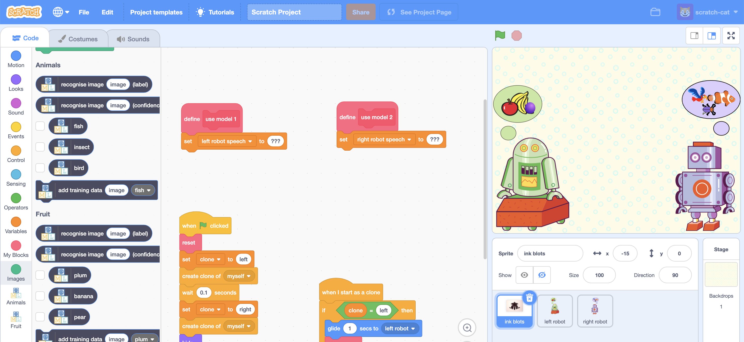
16. (BOTH students) Update the script so that it uses the **Fruit** ML model *The blocks for the two projects look the same. Make sure you get the one from the Fruit project.*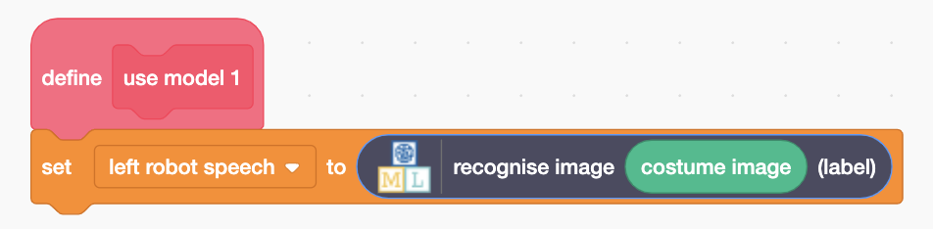
17. (BOTH students) Find the “**use model 2**” script, still in the ink blots sprite.
18. (BOTH students) Update the script so that it uses the **Animals** ML model *The blocks for the two projects look the same. Make sure you get the one from the Animals project.  
    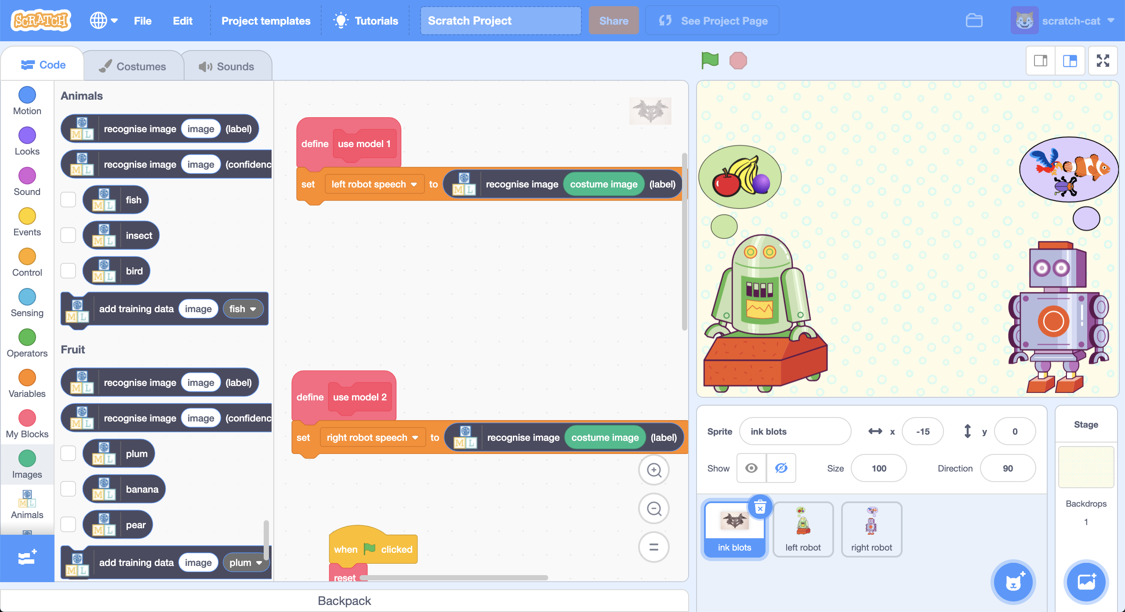*
19. (BOTH students) It’s time to test!  
    *Press the* ***Green Flag****An ink blot picture will be shown to both robots, and each of them will use their machine learning model to recognize what the ink blot looks like.****A screenshot of a computer

    Description automatically generated***
20. (BOTH students) Click the **Green Flag** again to try a different ink blot.

**What have you done?**

You’re giving the same pictures to two different machine learning models and asking them the same question – to recognize what they recognize in the picture.

Compare the answers that they’re giving.

Why do you think they don’t give the same answers?

Why does the green robot always say it thinks the ink blot looks like a fruit?

**Rorschach tests**

Asking someone to tell you the object that they can recognize in an ink blot painting is sometimes described as a “Rorschach test”.

Some people claim that you can use this as a psychological test, and that you can tell things about people’s character or emotions based on the answers that they give. (Not all psychologists think this is a useful test).

You trained two different machine learning models and performed a Rorschach test on both of them to compare their answers.

**Norman, the “psychopath” AI**

This project is a recreation of an artificial intelligence research project from MIT (Massachusetts Institute of Technology) in 2018.

They trained machine learning models to recognize what was in a picture, and tested them with ink blots (just as you have).

One of their machine learning models was trained to recognize upsetting things using training images from scary movies.

When tested with ink blot pictures, that ML model always gave answers that were scary or upsetting.

They called this ML model “Norman” and described it as the “world’s first psychopath AI” because it always gave disturbing answers to the ink blot picture tests.

You can learn more about this project at [**norman-ai.mit.edu**](http://norman-ai.mit.edu/)

What do you think? Why did “Norman” give upsetting answers to the ink blot test? Was this AI really a psychopath?

<http://norman-ai.mit.edu/#press> has links to how the media described this project. Do you agree with the descriptions of AI in those stories?